190905104
Parth Shukla
Lab 5

1) Write a producer and consumer program in C using the FIFO queue. The producer should write a set of 4 integers into the FIFO queue and the consumer should display the 4 integers.

// Producer

#include<stdio.h>
#include<stdlib.h>
#include<unistd.h>
#include<sys/types.h>
#include<limits.h>
#include<fcntl.h>
#include<sys/msg.h>
#include<sys/stat.h>
#include<string.h>

#define FIFO_NAME "my_fifo"
#define BUFFER_SIZE 1000

int main(int argc, char *argv[]){
int pipe_fd;
int res;
int open_mode=O_WRONLY;
int n=0;
char buffer[BUFFER_SIZE+1];

if(access(FIFO_NAME,F_OK)==-1){
res=mkfifo(FIFO_NAME,0777);
if(res!=0){
fprintf(stderr, "Could not create file%s\n",FIFO_NAME );
exit(EXIT_FAILURE);
}
}

printf("Process %d opening FIFO O_WRONLY\n",getpid());
pipe_fd = open(FIFO_NAME,open_mode);
printf("Process %d result %d\n",getpid(),pipe_fd);

if (pipe_fd!=-1){
printf("Enter 4 numbers\n");

while(n<4){
scanf("%s",buffer);
res=write(pipe_fd,buffer,BUFFER_SIZE);

if(res==-1){
fprintf(stderr, "Write Error on Pipe\n");
exit(EXIT_FAILURE);
}
n++;
}
(void)close(pipe_fd);
}
else
exit(EXIT_FAILURE);

printf("Process %d Finished\n",getpid() );
exit(EXIT_SUCCESS);

}

// Consumer

#include<stdio.h>
#include<stdlib.h>
#include<unistd.h>
#include<sys/types.h>
#include<limits.h>
#include<fcntl.h>
#include<sys/msg.h>
#include<sys/stat.h>
#include<string.h>

#define FIFO_NAME "my_fifo"
#define BUFFER_SIZE 1000

int main(int argc, char *argv[]){
int pipe_fd;
int res;
int open_mode=O_RDONLY;
int n=0;
char buffer[BUFFER_SIZE+1];
memset(buffer,'\0',sizeof(buffer));

printf("Process %d opening FIFO O_RDONLY\n",getpid());
pipe_fd=open(FIFO_NAME,open_mode);
printf("Process %d result %d\n",getpid(),pipe_fd);

if (pipe_fd!=-1){
do{
res=read(pipe_fd,buffer,BUFFER_SIZE);
printf("%s\n",buffer );
n++;
}while(n<4);

(void)close(pipe_fd);
}
else
exit(EXIT_FAILURE);

printf("Process %d Finished, %d bytes read\n",getpid(),n );
exit(EXIT_SUCCESS);
}
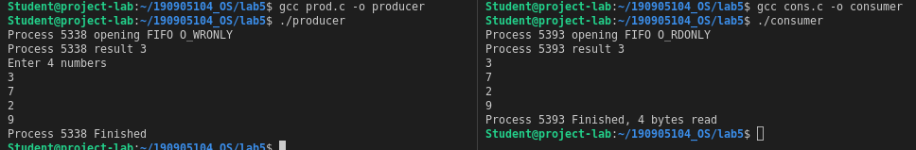

2) Demonstrate creation, writing to, and reading from a pipe.

#include<stdio.h>
#include<stdlib.h>
#include<unistd.h>
#include<sys/types.h>
#include<limits.h>
#include<fcntl.h>
#include<sys/msg.h>
#include<sys/stat.h>
#include<string.h>

int main(int argc, char* argv[]){
int n;
int fd[2];
char buf[1024];
char *data = "Hello from q2.c";
pipe(fd);

write(fd[1], data, strlen(data));
if((n=read(fd[0], buf, 1023)) >= 0){
buf[n] = '\0';
printf("Read %d bytes\n%s\n", n, buf);
}else{
perror("Read");
exit(0);
}
}

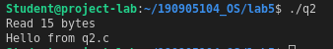

3) Write a C program to implement one side of FIFO.

// User 1 – First writes and then reads

#include<stdio.h>
#include<stdlib.h>
#include<unistd.h>
#include<sys/types.h>
#include<limits.h>
#include<fcntl.h>
#include<sys/msg.h>
#include<sys/stat.h>
#include<string.h>

#define FIFO_NAME "my_fifo"
#define BUFFER_SIZE 1000

int main(int argc, char *argv[]){
int pipe_fd;
int res;
int open_mode_write = O_WRONLY;
int open_mode_read = O_RDONLY;
int n=0;
char buffer[BUFFER_SIZE+1];

if(access(FIFO_NAME,F_OK)==-1){
res=mkfifo(FIFO_NAME,0777);
if(res!=0){
fprintf(stderr, "Could not create file%s\n",FIFO_NAME );
exit(EXIT_FAILURE);
}
}

while(1){
printf("Current mode: Writing\n");
pipe_fd = open(FIFO_NAME, open_mode_write);
printf("Enter message: ");
fgets(buffer, BUFFER_SIZE, stdin);
write(pipe_fd, buffer, BUFFER_SIZE);
close(pipe_fd);
printf("\n");

printf("Current mode: Reading\n");
pipe_fd = open(FIFO_NAME, open_mode_read);
res = read(pipe_fd, buffer, BUFFER_SIZE);
if(res == -1){
perror("Read");
exit(0);
}
printf("%s\n", buffer);
close(pipe_fd);

}
(void)close(pipe_fd);

printf("Process %d Finished\n",getpid() );
exit(EXIT_SUCCESS);
}

// User 2 – First reads and then writes back

#include<stdio.h>
#include<stdlib.h>
#include<unistd.h>
#include<sys/types.h>
#include<limits.h>
#include<fcntl.h>
#include<sys/msg.h>
#include<sys/stat.h>
#include<string.h>

#define FIFO_NAME "my_fifo"
#define BUFFER_SIZE 1000

int main(int argc, char *argv[]){
int pipe_fd;
int res;
int open_mode_write = O_WRONLY;
int open_mode_read = O_RDONLY;
int n=0;
char buffer[BUFFER_SIZE+1];

if(access(FIFO_NAME,F_OK)==-1){
res=mkfifo(FIFO_NAME,0777);
if(res!=0){
fprintf(stderr, "Could not create file%s\n",FIFO_NAME );
exit(EXIT_FAILURE);
}
}

while(1){

printf("Current mode: Reading\n");
pipe_fd = open(FIFO_NAME, open_mode_read);
res = read(pipe_fd, buffer, BUFFER_SIZE);
if(res == -1){
perror("Read");
exit(0);
}
printf("%s\n", buffer);
close(pipe_fd);

printf("Current mode: Writing\n");
pipe_fd = open(FIFO_NAME, open_mode_write);
printf("Enter message: ");
fgets(buffer, BUFFER_SIZE, stdin);
write(pipe_fd, buffer, BUFFER_SIZE);
close(pipe_fd);
printf("\n");
}
(void)close(pipe_fd);

printf("Process %d Finished\n",getpid() );
exit(EXIT_SUCCESS);
}

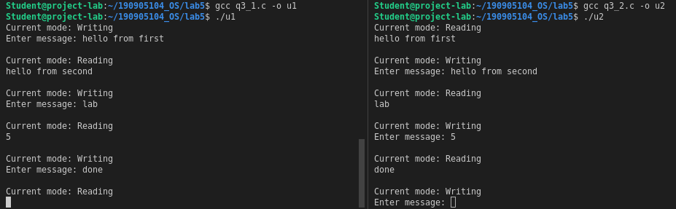

4) Write a C program reading and writing a binary file in C.

#include<stdio.h>
#include<stdlib.h>

int main(){
FILE* fptr;
int num=0;
fptr=fopen("q4.bin","wb+");

printf("Enter 5 numbers: \n");

for(int i = 0; i < 5; i++){
scanf("%d",&num);
fwrite(&num, sizeof(int), 1, fptr);
}

printf("Writing done!\n");
fclose(fptr);

fptr=fopen("q4.bin","rb");

for(int i = 0; i < 5; i++){
fread(&num,sizeof(int),1,fptr);
printf("%d\n",num);





